Assignment 2 : Part 2

Dheeraj M

Ee21btech11015

Observation :

Q3)

The graph output

The time taken by the summation method is more than the matrix method.

Q4)

Graph output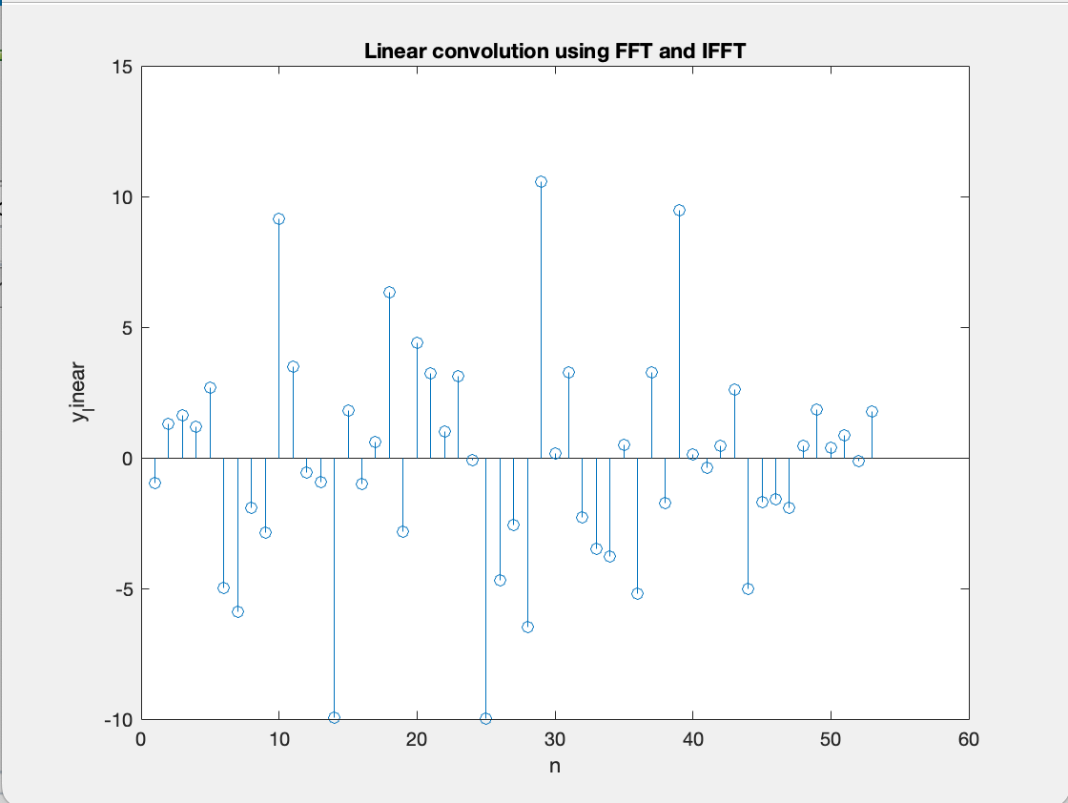

The Output of question 4 and question 3 is the same.